**Final Cut Pro Audio Output Settings**

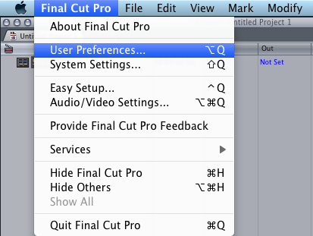

Go up to **Final Cut Pro** and select **User Preferences**.

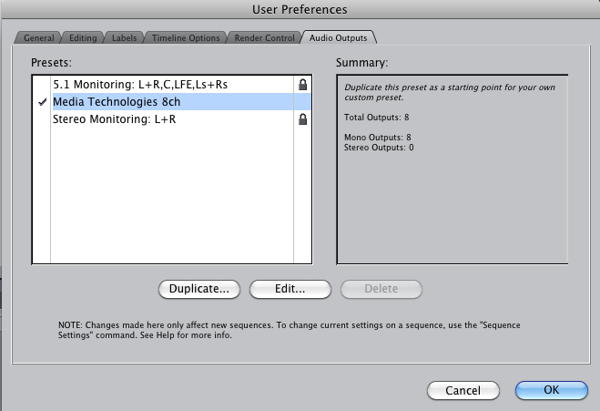

Make sure the “**Media Technologies 8ch**” custom preset is selected and that the summary column shows the total number of outputs as 8.

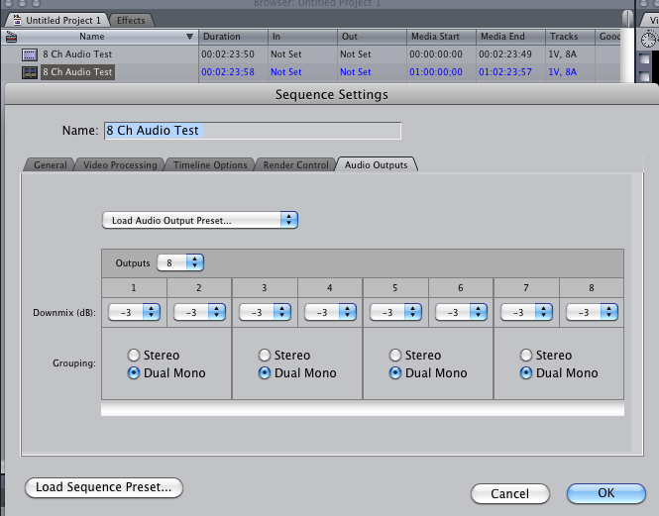

To check the number of audio channels your sequence is setup to output, right click the sequence and select **Sequence Settings**. The **Audio Outputs** tab should look like the screen shot above. If the settings don’t match, change them to the above settings. (Note: It appears the User Preference Preset overrides the sequence settings. You will need to make sure the user profile is set to the **Media Technologies 8Ch** custom preset.

**Final Cut Pro Audio Capture Settings**

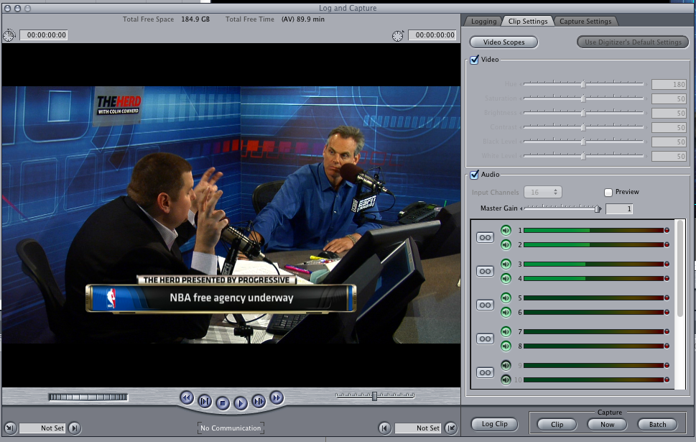 To check the number of audio channels being captured got to the **clip settings** tab from the log and capture window.

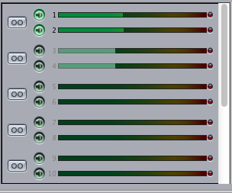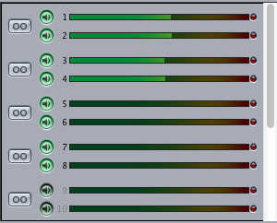

In order to capure more than 2 channels of audio, the speaker icons need to be bright green with the channel number visable as shown in the right screen grab. Macs 1-4 are currently set up to capture 8 channels of audio through Final Cut Pro.